**Network Models – Assignment (Properties)**

Problem Rewritten by Jill Nguyen

**Model:**

Parameters:

$R_{ij }$: Revenue received from investor $i for property j, where$ $i,j∈\left(1, 2, 3, 4\right)$

*Decisions:*

$x_{ij }$*: Whether property $j is sold to investor i,$ $where .$ $i,j∈\left(1, 2, 3, 4\right)$*

*Objective: Maximize revenue*

$max\sum_{ij}{ }x_{ij }$ ${ R}_{ij }$

*\**

*Constraints:*

$\sum_{i}{x_{ij }}≤ 1 \left(1\right)$*A property can be sold to maximum 1 investor*

$\sum_{j}{x_{1j}}≤2 ($*2) Investor 1 can purchase a maximum of 2 properties*

$\sum_{j}{x_{ij }}≤1$*(3) Demand of destination j must be satisfied, $i∈\left(2, 3, 4\right)$. Investors are willing to purchase at most 1 property*

$x_{ij }∈\left(0,1\right)$*(4) Binary variable for assignments*

**Optimal Solution:**

A maximum revenue of $805,000 can be attained by selling the properties to the investors as shown below.

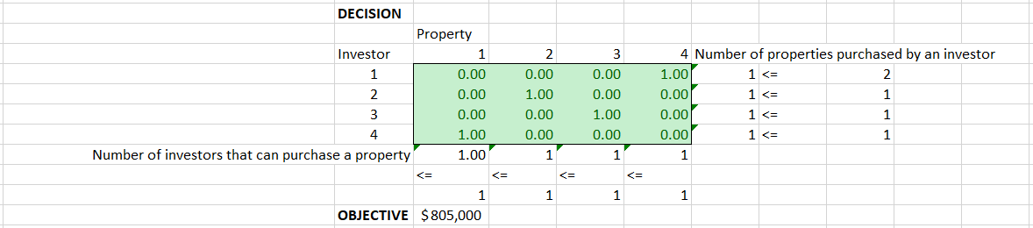

**Sensitivity Report:**

It is optimal to:

* sell property 1 to investor 4
* sell property 2 to investor 2
* sell property 3 to investor 3
* sell property 4 to investor 1

This solution gives a maximum profit of $805,000.

Reduced cost: The amount which be decrease from the total profit if the lower bound is increased.

Shadow price: The amount which would be added to total profit if there is an additional investor to buy and an additional property to sell.

